DECISION MEMORANDUM

TO: COMMISSIONER KJELLANDER
COMMISSIONER SMITH
COMMISSIONER HANSEN
JEAN JEWELL
RON LAW
BILL EASTLAKE
LOU ANN WESTERFIELD
RANDY LOBB
DAVE SCHUNKE
DON HOWELL
MICHAEL FUSS
BEV BARKER
GENE FADNESS
TONYA CLARK
WORKING FILE

FROM: LISA NORDSTROM

DATE: MAY 1, 2002

RE: IN THE MATTER OF THE APPLICATION TO APPROVE A CUSTOMER ALLOCATION AGREEMENT BETWEEN AVISTA CORPORATION AND THE CITY OF PLUMMER, CASE NO. AVU-E-02-3.

On March 11, 2002, Avista Corporation filed an Application for approval of a Customer Allocation Agreement between Avista and the City of Plummer. The Application notes that this filing is made pursuant to the Idaho Electric Supplier Stabilization Act (ESSA), Idaho Code § 61-332 et seq. In the Notice of Application and Modified Procedure issued on March 28, 2002, the Commission solicited comments regarding Avista’s Application. Order No. 28957. No comments were received other than those submitted by Commission Staff.

STATUTORY OVERVIEW
In December 2000 and February 2001, the Idaho Legislature amended portions of the ESSA. In particular, Idaho Code § 61-333 was amended to provide that all service agreements which allocate territory or customers between electric suppliers (such as Avista and Kootenai Electric) be filed with the Commission. Idaho Code § 61-333(1) now provides in pertinent part that
the commission shall after notice and opportunity for hearing, review and approve or reject [such] contracts…between cooperatives and public utilities….the commission shall approve such contracts only upon finding that the allocation of territories or consumers is in conformance with the provisions and purposes of this act.

Idaho Code § 61-333(1) (2001). As set out more fully in Idaho Code § 61-332, the purposes of the ESSA are to: (1) promote harmony among and between electric suppliers; (2) prohibit the “pirating” of consumers served by another supplier; (3) discourage duplication of electric facilities; (4) stabilize the territory and consumers served by the suppliers; (5) actively supervise certain conduct of the suppliers.
THE CUSTOMER ALLOCATION AGREEMENT
A document entitled “Assignment, Assumption and Release of Customer” (Customer Allocation Agreement or Agreement) was executed on February 27, 2002 and subsequently submitted for the Commission’s review. According to a Benewah County District Court document entitled “Stipulated Findings of Fact, Conclusions of Law, and Order,” the City of Plummer provided electrical service to Seeds, Inc. (Seeds) at its seed cleaning and processing facility located outside the City of Plummer (City) in the unincorporated area known as Tilma, Idaho. Case No. CV98-00425. The voltage of the electric current delivered to Seeds fluctuated considerably due to the length and condition of the electric supply line from the City of Plummer. According to the Court’s Order, this voltage situation caused Seeds to incur significant expense and hardship. While it found that Seeds was not entitled to damages or refund of past electric charges, the District Court held that Seeds could arrange for another electric supplier to provide service to its Tilma facility. The Court ordered the City of Plummer to allocate Seeds as a customer to the electric supplier of Seeds’ choice and continue supplying electricity until another supplier was willing and able to supply power to Seeds.
After providing background information regarding the Court proceeding, the Agreement stated that Avista was willing to provide electric service to the facility. Id. Thus, the City agreed to assign its right to Avista to provide electric service to Seeds. Id. Avista agreed to assume the obligation to provide electric service to Seeds under the rates, rules and regulations authorized by the Idaho Public Utilities Commission. Id. The City also agreed to release Seeds as a customer on the City’s electric system and disconnect Seeds from the City’s system when requested by Avista to do so. Id. Avista and the City also agreed to several other provisions for amendment, assignment, indemnification and severability of the Agreement. Id. at 1-2.
STAFF COMMENTS
Staff reviewed the Application and discussed the filing with the City of Plummer, Avista, and Seeds, Inc. According to Staff, Seeds clearly experienced significant service quality problems as a customer of the City, which the District Court sought to resolve by allowing Seeds to arrange for another utility company to provide service to Seeds at Tilma. Staff believes Avista is the most appropriate alternate service provider since Avista’s facilities are approximately 800 feet from the Seeds facility, whereas the next nearest provider is roughly 8 miles away. Avista’s nearest facilities have the capacity to serve the Seeds load and Avista is willing to provide service to Seeds.
Avista has proposed to serve Seeds through Schedule 21 – Large General Service. Staff believes this is the most appropriate service schedule for Seeds. Although the Company’s line extension tariff provides an allowance that exceeds connection costs, Seeds will be responsible for removing and replacing metering and related service materials prior to connection. Because Seeds will be serviced under Avista’s approved tariff schedule and line extension tariff that generally reflect cost of service, the addition of Seeds to Avista’s system should not unduly burden the existing customers.
In short, Staff recommends approval of the Customer Allocation Agreement because the Agreements will effectuate the District Court Order, improve service quality for Seeds, Inc, and will not harm Avista’s other customers.
COMMISSION DECISION
Does the Commission wish to approve the Customer Allocation Agreement between Avista and the City of Plummer?

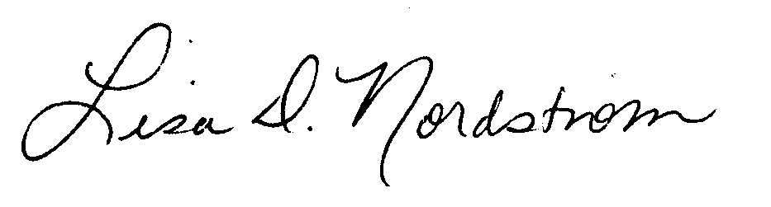
Lisa D. Nordstrom

M:AVUE0203_ln2

