May 10, 2000

VIA FACSIMILE

John D. Heffner, Esq.
Rea, Cross & Auchincloss
1707 L Street NW, Suite 570
Washington, DC 20036

RE: STB Docket AB-No. 564, Camas Prairie’s Abandonment of the Grangeville-Spalding Line

Dear Mr. Heffner:
Pursuant to our telephone conversation last week, I have enclosed for your review a copy of Idaho Code § 62-424. This statute requires the Commission to conduct a public hearing when a railroad proposes to abandon a branch line within the state of Idaho.

As indicated in Camas Prairie’s Notice of Intent, “[a]ny documentation in the Railroad’s possession will be made available promptly to those requesting it.” Notice of Intent at 2. Following up on my earlier request of March 2, 2000, could you please provide me with copies of documents that the Railroad indicated in its draft Environmental and Historical Report that it possesses specifically: property deeds, profile maps, right-of-way maps, bridge engineering reports, and “engineering maps” pertaining to the Grangeville line. In addition, could you please provide me with the estimated net liquidation value (NLV) of the line and the amount of the annual subsidy necessary to keep the entire line in operation.

Given the expedited nature of the STB abandonment proceeding, I would also like to ask for other documents or information in this proceeding. More specifically, please provide me:

(1) Any appraisal, report, evaluation, or analysis concerning the valuation of the Camas Prairie system which was prepared by Camas Prairie or RailNet at the time RailNet purchased the Camas Prairie system from the prior owners.

(2) Any salvage bids or estimates prepared and supporting workpapers calculating the salvage values of railroad ties, rails, bridges/trestles, and other track structures on the second subdivision.

(3) Please describe all derailments which have occurred in the last three years including the date of occurrence, milepost location, number of cars involved, amount and type of cargoes involved, and whether there was any release of hazardous materials which resulted in a clean-up or remediation.

I would appreciate that the documents and information requested be provided no later than simultaneously with Camas Prairie’s Abandonment Application. In addition, please provide all workpapers and supporting documents to the Application itself.

If you have any questions regarding this request, please contact me at (208) 334-0312.

Sincerely yours,

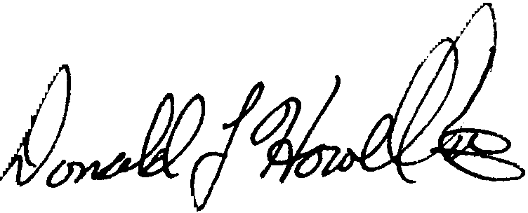

Donald L. Howell, II
Deputy Attorney General

Enclosures

cc: | Ron Law

Vld/L:Heffner_dh2

